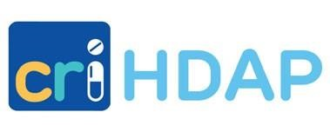

HIV Drug Assistance Program¹
Open Formulary Exclusions

HDAP can only cover FDA-approved medications.
Medications must be prescribed by a clinician.

Specific Exclusions
Medication | Notes
Finasteride (Propecia) | Approved for prostate disorders only (PA required)
Minoxidil (Rogaine)

Class Exclusions
Medication Type | Notes
Cosmetic Medications
Herbal Medications
Erectile Dysfunction Medications | Covered for insured clients only (no PA required)
Fertility Medications | Covered for insured clients only (no PA required)

Revised 1/2025

¹ A program of the Massachusetts Department of Public Health

